2B Displaying Single Data Sets – Lesson 9
Statistics – Five Number Summaries.

Name: _________________
- What is an five-number summary?

- For the five-number summary 6, 12, 34, 78, 98 name the following.

- Median ___  - Lower Extreme ___  - Upper Quartile – Q3 ___ | - Upper Extreme ___  - Lower Quartile ___

- For the five-number summary 61, 92, 134, 278, 298 name the following.

- Lower Extreme ___  - Median ___  - Upper Extreme ___ | - Lower Quartile ___  - Upper Quartile – Q3 ___

- For the stem-and-leaf plot circle the following.

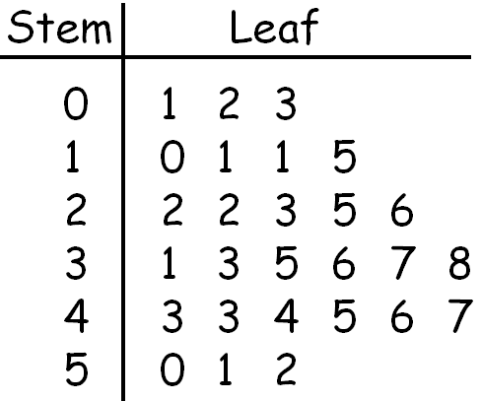
  - Median ____

  - Lower Quartile Q1 ____

  - Upper Quartile Q3 ____

  - Lower Extreme ____

  - Upper Extreme ____

  - Draw a box-and-whisker plot

- For the stem-and-leaf plot circle the following.
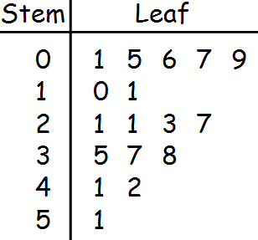
  - Median ____

  - Lower Quartile Q1 ____

  - Upper Quartile Q3 ____

  - Lower Extreme ____

  - Upper Extreme ____

  - Draw a box-and-whisker plot

- For the stem-and-leaf plot circle the following.
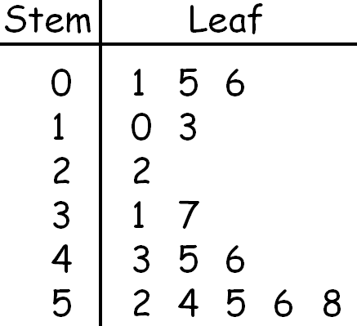
  - Median ____

  - Lower Quartile Q1 ____

  - Upper Quartile Q3 ____

  - Lower Extreme ____

  - Upper Extreme ____

  - Draw a box-and-whisker plot

